July 28, 2021

Mr. Kevin J. Kramp
Director, Office of Regulatory Policy
Farm Credit Administration
1501 Farm Credit Drive
McLean, VA 22102-5090

Re: Advance Notice of Proposed Rulemaking – 12 CFR Part 615 – RIN 3052-AD44; Bank Liquidity Reserve; 86 Federal Register 34645-34653

Dear Mr. Kramp:

On behalf of the Farm Credit System, Farm Credit Council (“FCC”) appreciates the opportunity to comment on the Farm Credit Administration’s (“FCA”) Advance Notice of Proposed Rulemaking (“ANPRM”) regarding Bank Liquidity Reserve regulations that was published in the June 30, 2021 Federal Register.

Given the complexity and highly technical nature of the ANPRM, FCC respectfully requests a comment period extension of 60 days (beyond the current comment deadline of September 28, 2021) to appropriately respond to the agency’s request for public comment. We believe FCA will be better served with more complete feedback from the Farm Credit System given the anticipated impact to the existing liquidity framework.

Thank you in advance for your time and consideration in reviewing this request. Should you have any questions, please do not hesitate to contact me.

Sincerely,
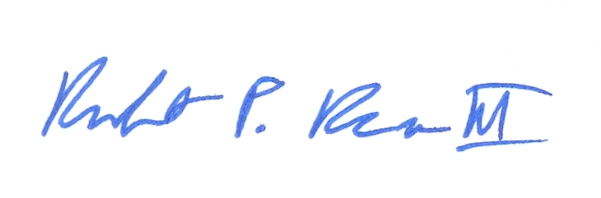
Robert Paul Boone, III
SVP, General Counsel

