December 4, 2024
Autumn R. Agans, Deputy Director Office of Regulatory Policy Farm Credit Administration
1501 Farm Credit Drive
McLean, VA 22102-5090
Re: Response to Advance Notice of Proposed Rulemaking – Loans to Similar Entities, Farm Credit Administration, Agency; 12 CFR Part 613; RIN 3052-AD58; 89 FR 72759 (Sep. 6, 2024)
Dear Ms. Agans:
AgFirst Farm Credit Bank (“AgFirst”) appreciates the opportunity to comment on the Farm Credit Administration’s (the “FCA”) Advance Notice of Proposed Rulemaking (the “ANPRM”) that was published in the Federal Register on September 6, 2024, relating to similar entity lending activity. See 89 FR 72759.
In response to FCA’s ANPRM, FCC assembled and coordinated a multi-disciplinary workgroup of experts (the “Workgroup”), representing Farm Credit System associations and banks, who met over the course of several weeks to analyze and comment on FCA’s inquiries in the ANPRM based on, among other things, the Farm Credit Act of 1971, as amended (the “Act”), existing FCA regulations, published guidance, and experiences with, and knowledge of, similar entity lending practices, Congressional intent, and safety and soundness considerations. AgFirst had representation on the Workgroup and fully supports FCC’s response. Furthermore, AgFirst would like to emphasize its support of the following issues identified in FCC’s comment letter to the ANPRM:
- Broad Congressional Intent: Shortly after the 1980s farm crisis, Congress granted similar entity lending authority to the Farm Credit System (the “System”) to reduce concentration risk and ensure financial stability. Initially given by Congress to banks for cooperatives in 1992 and extended to the remainder of the System in 1994, this similar entity lending authority aimed to diversify risk by geography, industry, and account exposure through collaboration between System institutions and the commercial banking industry. Consistent with contemporary Congressional statements, FCA’s initial and amended similar entity rules did not attempt to define the types of entities that may qualify as similar entities. Rather, the regulations appropriately support a broad and flexible application of this authority, which AgFirst and the rest of the System has relied on for over three decades to navigate challenges such as natural disasters, tragedies, and a global pandemic.

- Risk Diversification: Similar entity lending allows AgFirst to diversify its loan portfolio by participating in loans with non-system lenders. This diversification reduces the risk associated with lending primarily to the agricultural sector. By spreading financial exposure across a broader range of investments, AgFirst can better manage potential losses and maintain a strong financial position.

- Enhanced Financial Stability: Engaging in similar entity loans contributes to the financial strength of AgFirst, enabling it to support a wider array of agricultural and rural infrastructure projects. These loans provide additional revenue streams and help stabilize the System’s financial health, ensuring it can continue to fulfill its mission of providing reliable credit to American farmers and ranchers. The financial benefits gained from these loans are reinvested into the AgFirst District, further supporting its commitment to serving rural communities.

- Support for Rural Development: Similar entity lending authority allows AgFirst to participate in financing projects that benefit rural areas, such as the entire food and fiber supply chain and infrastructure development. By partnering with non-system lenders, AgFirst can support larger and more diverse projects that might be beyond its capacity alone. This collaboration not only helps manage financial risk but also promotes the growth and development of rural communities, aligning with the System’s mission to enhance the quality of life in rural America.

- Reputational Risk Management: AgFirst concurs with FCC’s stance that the FCA should not conflate compliance with regulatory and legal requirements with reputational risk management. AgFirst acknowledges that managing reputational risk is essential for maintaining the trust and confidence of stakeholders in the System. Effective reputational risk management ensures that the System can continue to fulfill its mission of providing reliable credit to American farmers and ranchers while preserving its integrity and public image. Consequently, AgFirst employs robust policies and procedures to manage reputational risk and believes it would be inappropriate for the FCA to further restrict the System’s participation authority based on perceived reputational risks associated with similar entity activities.

AgFirst appreciates the opportunity to provide context to why it does not believe it is necessary or even appropriate to propose a regulation that would seek to limit the System’s ability to utilize its statutory authorities in the ways contemplated by the questions. We trust that our comments, as well as those comment submitted by FCC and other System associations and banks, will assist FCA in such efforts.

Respectfully submitted,
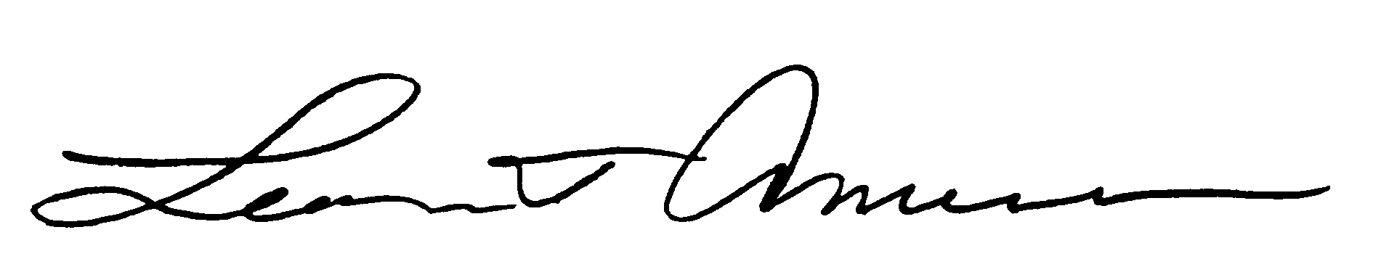
Leon T. Amerson
Chief Executive Officer & President
AgFirst Farm Credit Bank

The Farm Credit Bank and Associations Safety and Soundness Act (the “1992 Act”).
The Farm Credit System Agricultural Export and Risk Management Act (the “1994 Act”).

